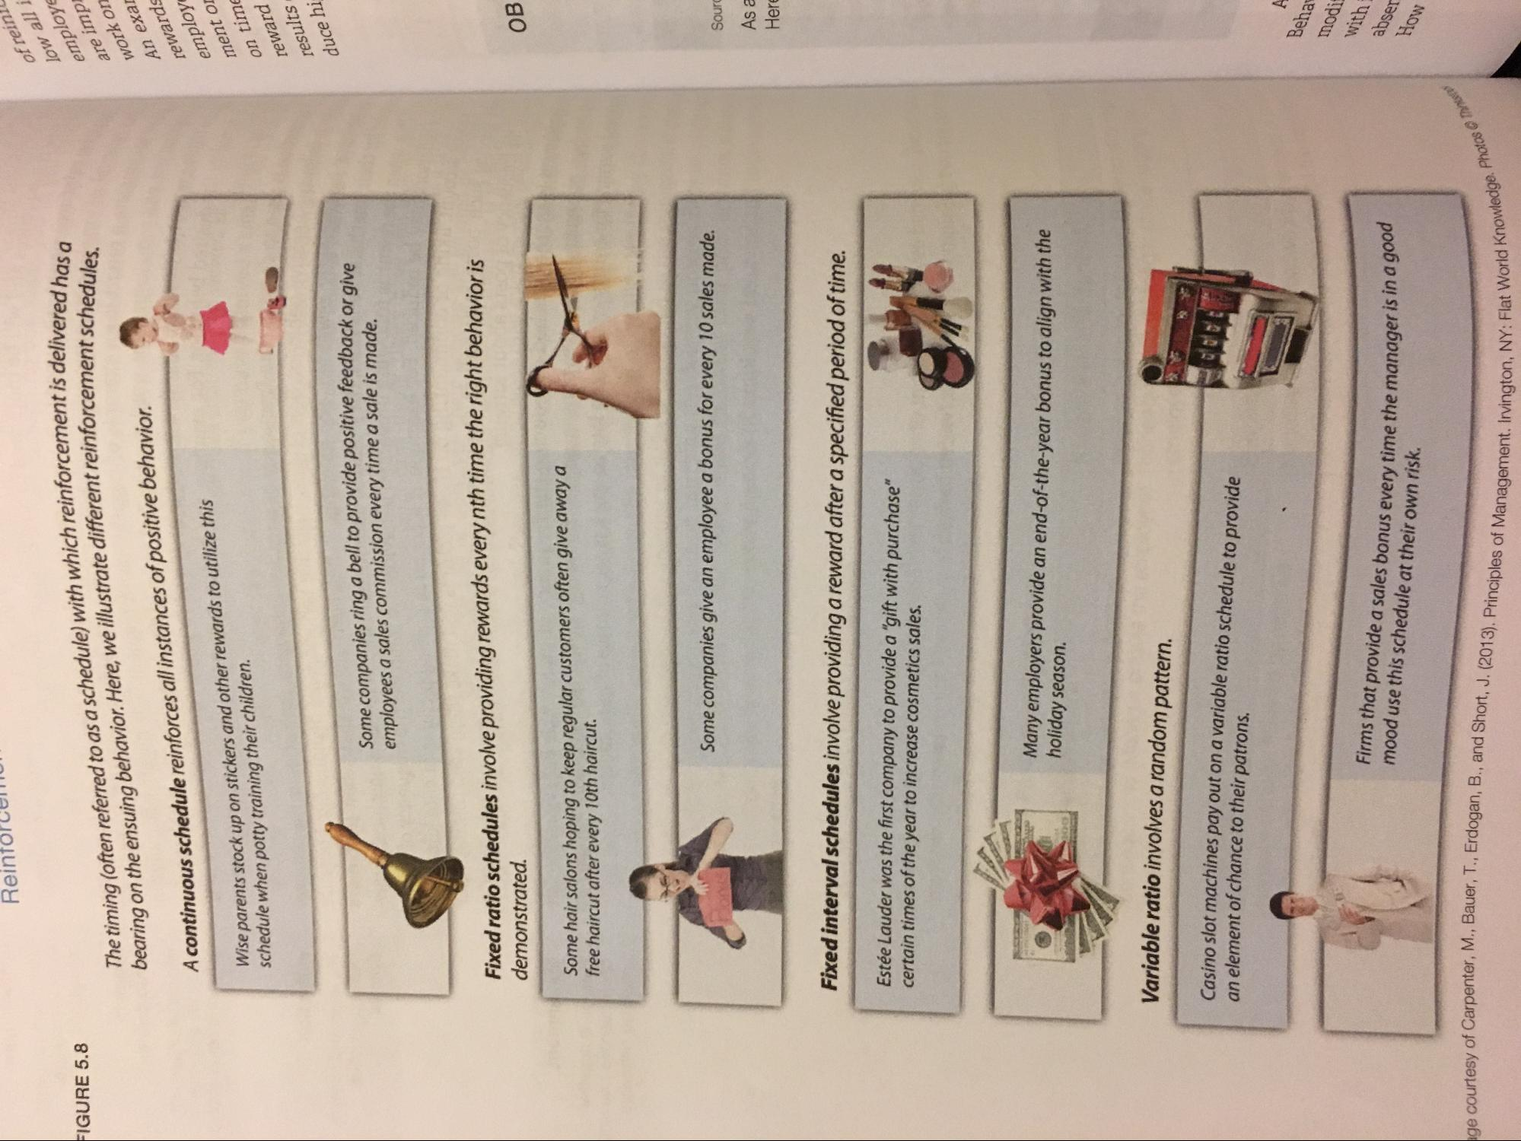
Reintorcenom
The timing (often referred to as a schedule) with which reinforcement is deli bearing on the ensuing behavior. Here, we illustrate different reinforcement scher
FIGURE 5.8
orcement is delivered has a
forcement schedules.
of reinil low all í employe are imp work on An exar rewards
A continuous schedule reinforces all instances of positive behavior.
Wise parents stock up on stickers and other rewards to utilize this schedule when potty training their children.
employ ment oL on time reward results duce hi
Some companies ring a bell to provide positive feedback or give employees a sales commission every time a sale is made.
Fixed ratio schedules involve providing rewards every nth time the right behavior is demonstrated.
ов
Some hair salons hoping to keep regular customers often give away a free haircut after every 10th haircut.
Some companies give an employee a bonus for every 10 sales made.
Sourc
As a Here
Fixed interval schedules involve providing a reward after a specified period of time.
Estée Lauder was the first company to provide a "gift with purchase" certain times of the year to increase cosmetics sales.
Many employers provide an end-of-the-year bonus to align with the holiday season.
Variable ratio involves a random pattern.
an element of chance to their patrons. Casino slot machines pay out on a variable ratio schedule to provide
A
Behar
modi with
Firms that provide a sales bonus every time the manager is in a good mood use this schedule at their own risk.
abser How
age. Photos
Carpenter, M., Bauer, T., Erdogan, B., and Short, J. (2013) Princinle
gton, NY: Flat World Knowledge.

